A partir de la versión 5.3 la clase navbar-dark quedo obsoleta y lo cambiaion:
<nav class="navbar navbar-expand-sm navbar-dark bg-dark" aria-label="Third navbar example"> <div class="container-fluid" bis_skin_checked="1"> <a class="navbar-brand" href="#">Expand at sm</a> <button class="navbar-toggler" type="button" data-bs-toggle="collapse" data-bs-target="#navbarsExample03" aria-controls="navbarsExample03" aria-expanded="false" aria-label="Toggle navigation"> <span class="navbar-toggler-icon"></span> </button> <div class="collapse navbar-collapse" id="navbarsExample03" bis_skin_checked="1"> <ul class="navbar-nav me-auto mb-2 mb-sm-0"> <li class="nav-item"> <a class="nav-link active" aria-current="page" href="#">Home</a> </li> <li class="nav-item"> <a class="nav-link" href="#">Link</a> </li> <li class="nav-item"> <a class="nav-link disabled" aria-disabled="true">Disabled</a> </li> <li class="nav-item dropdown"> <a class="nav-link dropdown-toggle" href="#" data-bs-toggle="dropdown" aria-expanded="false">Dropdown</a> <ul class="dropdown-menu"> <li><a class="dropdown-item" href="#">Action</a></li> <li><a class="dropdown-item" href="#">Another action</a></li> <li><a class="dropdown-item" href="#">Something else here</a></li> </ul> </li> </ul> <form role="search"> <input class="form-control" type="search" placeholder="Search" aria-label="Search"> </form> </div> </div> </nav>

navbar-dark:ESTO NO!! DEPRECATED CACA DE LA VACA : en su lugar esto:
data-bs-theme="dark"
es más la página de Bootstrap lo deja claro clarinete
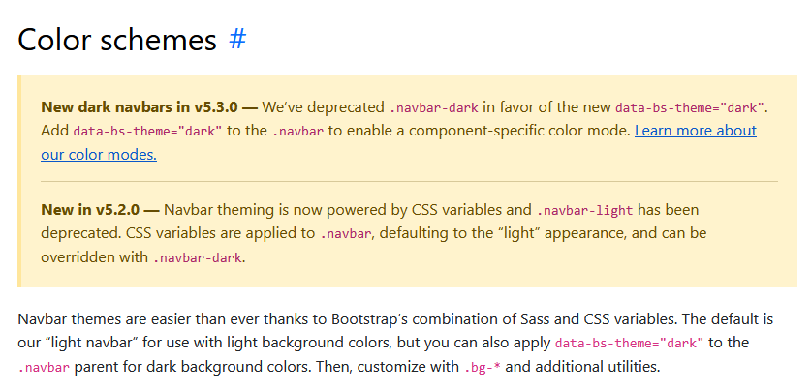

El resultado tras los cambios:
<nav class="navbar navbar-expand-sm bg-dark" data-bs-theme="dark" aria-label="Third navbar example"> <div class="container-fluid" bis_skin_checked="1"> <a class="navbar-brand" href="#">INFOEX</a> <button class="navbar-toggler" type="button" data-bs-toggle="collapse" data-bs-target="#navbarsExample03" aria-controls="navbarsExample03" aria-expanded="false" aria-label="Toggle navigation"> <span class="navbar-toggler-icon"></span> </button> <div class="collapse navbar-collapse" id="navbarsExample03" bis_skin_checked="1"> <ul class="navbar-nav me-auto mb-2 mb-sm-0"> <li class="nav-item"> <a class="nav-link active" aria-current="page" href="#">Inicio</a> </li> <li class="nav-item"> <a class="nav-link" href="#">Contacto</a> </li> <li class="nav-item"> <a class="nav-link" href="#">Sobre nosotros</a> </li> <li class="nav-item dropdown"> <a class="nav-link dropdown-toggle" href="#" data-bs-toggle="dropdown" aria-expanded="false">Aciones</a> <ul class="dropdown-menu"> <li><a class="dropdown-item" href="#">Inciar Sesión</a></li> <li><a class="dropdown-item" href="#">Registrarse</a></li> <li><a class="dropdown-item" href="#">Acerca de..</a></li> </ul> </li> </ul> <form role="search"> <input class="form-control" type="search" placeholder="Búsqueda" aria-label="Search" data-bs-theme="light"> </form> </div> </div> </nav>

